Q1.

About.js:

import React from 'react';

function About() {

  return (

    <div className="container">

      <h1 className="display-4">About Us</h1>

      <p className="lead">This iss about page.</p>

    </div>

  );

}

export default About;

Contact.js

import React from 'react';

function Contact() {

  return (

    <div className="container">

      <h1 className="display-4">Contact Us</h1>

      <p className="lead">You can contact us using the form below:</p>

      <form>

        <div className="mb-3">

          <label htmlFor="name" className="form-label">Name</label>

          <input type="text" className="form-control" id="name" />

        </div>

        <div className="mb-3">

          <label htmlFor="email" className="form-label">Email address</label>

          <input type="email" className="form-control" id="email" />

        </div>

        <div className="mb-3">

          <label htmlFor="message" className="form-label">Message</label>

          <textarea className="form-control" id="message" rows="5"></textarea>

        </div>

        <button type="submit" className="btn btn-primary">Submit</button>

      </form>

    </div>

  );

}

export default Contact;

Home.js

import React from 'react';

function Home() {

  return (

    <div className="container">

      <h1 className="display-4">Welcome to my Single-Page Application!</h1>

      <p className="lead">This is the Home page.</p>

    </div>

  );

}

export default Home;

App.js:

import React, { useState } from 'react';

import Home from './components/Home';

import About from './components/About';

import Contact from './components/Contact';

function App() {

  const [activeComponent, setActiveComponent] = useState('home');

  const renderComponent = () => {

    switch (activeComponent) {

      case 'home':

        return <Home />;

      case 'about':

        return <About />;

      case 'contact':

        return <Contact />;

      default:

        return null;

    }

  };

  return (

    <div className="container">

      <nav className="navbar navbar-expand-lg navbar-light bg-light">

        <div className="container-fluid">

          <a className="navbar-brand" href="#">My Single-Page Application</a>

          <button className="navbar-toggler" type="button" data-bs-toggle="collapse" data-bs-target="#navbarNav" aria-controls="navbarNav" aria-expanded="false" aria-label="Toggle navigation">

            <span className="navbar-toggler-icon"></span>

          </button>

          <div className="collapse navbar-collapse" id="navbarNav">

            <ul className="navbar-nav">

              <li className={`nav-item ${activeComponent === 'home' ? 'active' : ''}`} onClick={() => setActiveComponent('home')}>

                <a className="nav-link" href="#">Home</a>

              </li>

              <li className={`nav-item ${activeComponent === 'about' ? 'active' : ''}`} onClick={() => setActiveComponent('about')}>

                <a className="nav-link" href="#">About</a>

              </li>

              <li className={`nav-item ${activeComponent === 'contact' ? 'active' : ''}`} onClick={() => setActiveComponent('contact')}>

                <a className="nav-link" href="#">Contact</a>

              </li>

            </ul>

          </div>

        </div>

      </nav>

      <main className="mt-4">

        {renderComponent()}

      </main>

    </div>

  );

}

export default App;

Index.js:

import React from 'react';

import ReactDOM from 'react-dom/client';

import './index.css';

import App from './App';

import reportWebVitals from './reportWebVitals';

import { BrowserRouter } from 'react-router-dom';

import './bootstrap.min.css';

const root = ReactDOM.createRoot(document.getElementById('root'));

root.render(

  <React.StrictMode>

    <App />

  </React.StrictMode>

);

// If you want to start measuring performance in your app, pass a function

// to log results (for example: reportWebVitals(console.log))

// or send to an analytics endpoint. Learn more: <https://bit.ly/CRA-vital>

OUTPUTS:

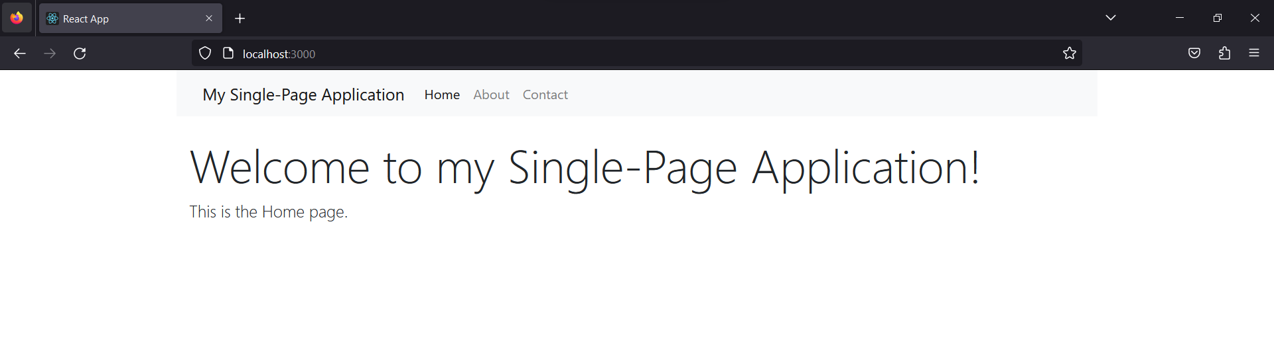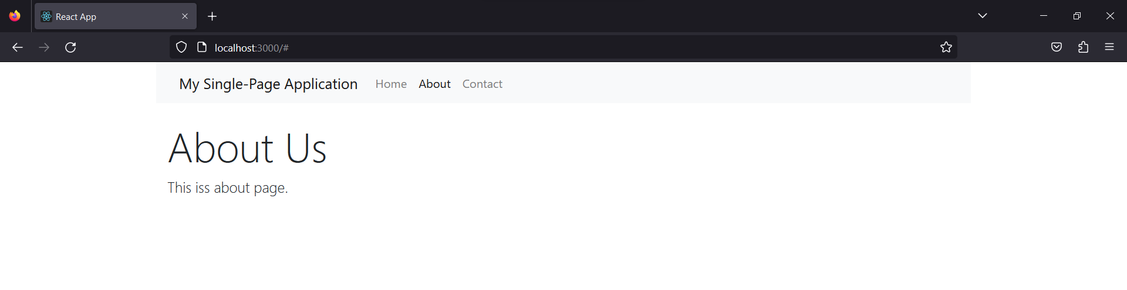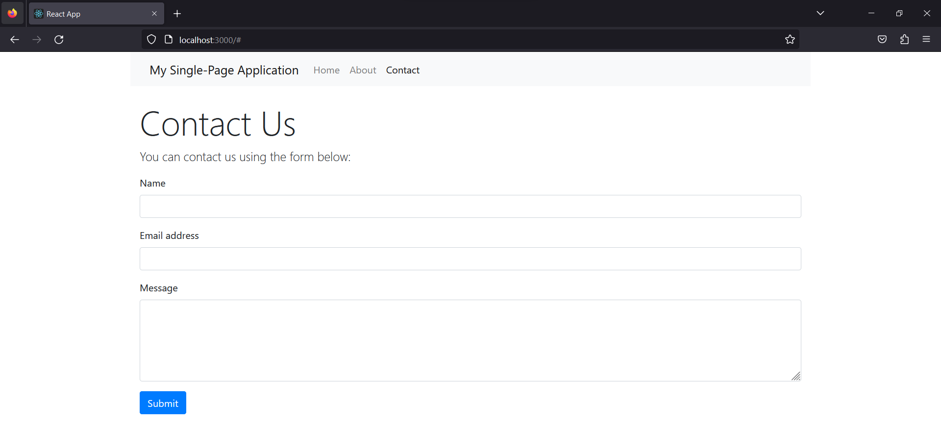

Q2:

App.js:

import React, { useState } from 'react';

function Calculator() {

  const [inputValue, setInputValue] = useState('0');

  const [operator, setOperator] = useState(null);

  const [previousValue, setPreviousValue] = useState(null);

  const handleDigitClick = (digit) => {

    setInputValue((prevValue) => {

      if (prevValue === '0') {

        return digit;

      } else {

        return prevValue + digit;

      }

    });

  };

  const handleOperatorClick = (op) => {

    if (operator === null) {

      setOperator(op);

      setPreviousValue(parseFloat(inputValue));

      setInputValue('0');

    } else {

      const currentValue = parseFloat(inputValue);

      let result;

      switch (operator) {

        case '+':

          result = previousValue + currentValue;

          break;

        case '-':

          result = previousValue - currentValue;

          break;

        case '\*':

          result = previousValue \* currentValue;

          break;

        case '/':

          result = previousValue / currentValue;

          break;

        default:

          result = currentValue;

      }

      setOperator(op);

      setPreviousValue(result);

      setInputValue('0');

    }

  };

  const handleEqualsClick = () => {

    const currentValue = parseFloat(inputValue);

    let result;

    switch (operator) {

      case '+':

        result = previousValue + currentValue;

        break;

      case '-':

        result = previousValue - currentValue;

        break;

      case '\*':

        result = previousValue \* currentValue;

        break;

      case '/':

        result = previousValue / currentValue;

        break;

      default:

        result = currentValue;

    }

    setInputValue(result.toString());

    setOperator(null);

    setPreviousValue(null);

  };

  const handleClearClick = () => {

    setInputValue('0');

    setOperator(null);

    setPreviousValue(null);

  };

  return (

    <div>

      <input type="text" value={inputValue} readOnly />

      <div>

        <button onClick={() => handleDigitClick('1')}>1</button>

        <button onClick={() => handleDigitClick('2')}>2</button>

        <button onClick={() => handleDigitClick('3')}>3</button>

        <button onClick={() => handleOperatorClick('+')}>+</button>

      </div>

      <div>

        <button onClick={() => handleDigitClick('4')}>4</button>

        <button onClick={() => handleDigitClick('5')}>5</button>

        <button onClick={() => handleDigitClick('6')}>6</button>

        <button onClick={() => handleOperatorClick('-')}>-</button>

      </div>

      <div>

        <button onClick={() => handleDigitClick('7')}>7</button>

        <button onClick={() => handleDigitClick('8')}>8</button>

        <button onClick={() => handleDigitClick('9')}>9</button>

        <button onClick={() => handleOperatorClick('\*')}>\*</button>

      </div>

      <div>

        <button onClick={() => handleDigitClick('0')}>0</button>

        <button onClick={() => handleClearClick()}>C</button>

        <button onClick={() => handleEqualsClick()}>=</button>

        <button onClick={() => handleOperatorClick('/')}>/</button>

      </div>

    </div>

 );

}

export default Calculator;

Output:

